Client Intake Information
The information requested below will assist me in treating you safely. Feel free to ask any questions about the information being requested. Please note that all information provided below will be kept confidentially unless allowed or required by law. Your written permission will be required to release any information.
Name: ____________________________________________________ Phone #: _________________________________________
Address: ___________________________________________________________________________________________________
E-mail: _____________________________________________________ Occupation: _____________________________________
Date of Birth: ______________________________________ Referred by: ______________________________________________
Emergency Contact: _________________________________________ Phone #: _________________________________________
Please answer the following questions to the best of your knowledge.
Have you received massage therapy before? □ Yes □ No If yes, how often? ___________________________________________
Primary reason for today’s massage? ___________________________________________________________________________
Do you have any allergies to oils, lotions, ointments, fruits, or nuts? □ Yes □ No
If yes, please explain: ________________________________________________________________________________________
Are you wearing any of the following? (Check all that apply)
□ Contact Lenses □ Hearing Aid □ Dentures □ Prosthetics
Do you sit for long hours at a work station, computer, or driving? □ Yes □ No
If yes, please describe: _______________________________________________________________________________________
What are your hobbies? ______________________________________________________________________________________
What would you say your energy level is on average? □ Low □ Moderate □ High
Describe any physical activities you do on a regular basis (gym, sports, gardening, etc):
_________________________________________________________________________________________________________
Please indicate conditions you are experiencing or have experienced:
Cardiovascular Infections Head/Neck
□ High blood pressure □ Hepatitis □ Headaches
□ Low blood pressure □ Skin conditions □ Migraines
□ Congestive heart failure □ TB □ Allergies
□ Heart attack □ HIV □ Vision problems/loss
□ Phlebitis/varicose veins □ Herpes □ Ear problems/hearing loss
□ stroke/CVA □ Athlete’s Foot □ Thyroid Disease
□ Pacemaker or similar device □ Warts □ TMJ
□ Heart disease
Respiratory Other Women
□ Pneumonia □ Diabetes □ Pregnant? If yes, how many months? _______
□ Shortness of breath □ Loss of sensation □ Gynecological conditions, what? ___________
□ Bronchitis □ Numbness
□ Asthma □ Tingling Psychological
□ Emphysema □ Epilepsy □ Anxiety/Stress
□ Chronic cough □ Cancer, where? _______________ □ Depression
Digestion □ Skin conditions, what? □ Insomnia
□ Ulcer ________________________________
□ Diarrhea □ Arthritis Other
□ Constipation □ Bursitis □ Drug Use □ Tobacco Use
□ Nausea □ Sciatica □ Alcohol Use How often? _____________
Are you currently under medical supervision? □ Yes □ No If yes, please explain: ________________________________________
Do you see a chiropractor? □ Yes □ No If yes, please explain: ______________________________________________________
Are you currently taking any medications? □ Yes □ No If yes, please list: _______________________________________________
Is there anything else about your health history that you think would be useful for your massage therapist to know to plan a safe and effective massage session for you?

____________________________________________________________________________________________________________
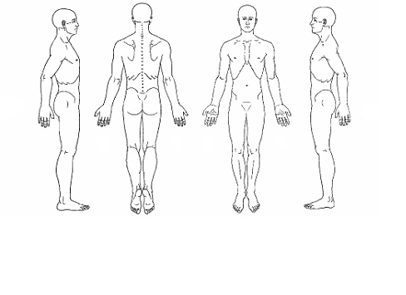__________________________________________________________________________________________________

Please use an “x” to indicate areas of discomfort.
Please read and sign below:
I, ________________________________________ (print name) understand that the massage/bodywork I receive is provided for stress management, reduction of muscular tension, increasing circulation, and developing body awareness. If I experience any pain or discomfort during my session, I will immediately inform the therapist so that the pressure and/or strokes may be adjusted to my level of comfort.
I further understand that massage should not be construed as a substitute for medical examination, diagnosis, or treatment and that I should see a physician or other qualified medical specialist for any mental or physical ailment that I am aware of.
I understand that massage therapists are not qualified to perform spinal or skeletal adjustments, diagnose, prescribe, or treat any physical or mental illness, and that nothing said in the course of the session given should be construed as such. Because massage/bodywork should not be performed under certain medical conditions, I affirm that I have stated all my known medical conditions, and answered all questions honestly.
I agree to keep the therapist updated as to any changes in my medical profile and understand that there shall be no liability on the therapist’s part should I fail to do so.
I also understand that any illicit or sexually suggestive remarks or advances made by me will result in immediate termination of the session, and I will be liable for payment of the scheduled appointment.

Client Signature: _______________________________________________________ Date: _________________________________
Practitioner Signature: __________________________________________________ Date: _________________________________

